Core Portal|Employee Self Service
Contents
Document Version Control 1
Approved process for raising 1
Consultation & Approval 1
Change Management 1
How to 1
Testing 2
Communications 2
Downstream Systems & Processes 2
Affected Reports 2
Additional Background Information 2

Document Version Control
Change History/Review Details
Date | Version | Review by | Summary of Change
23 Jan 19 | 0.1 | HC | Draft
4 Apr 23 | 0.2 | HC | Updated

Approved process for raising - TBC
A request for change is likely to be the result of a Business Change Process or possibly a technical fix.

Consultation & Approval - TBC
There are a number of groups who may need to approve changes to the ESS and/or MSS portal before they are made.

As a guide approval should be sought from the following as applicable:

HR Policy team about Contract Details and what Managers have access to, Equality and Diversity team (Diversity data), Payroll (payslip and P60 data), HR Information team (Academic related details), Staff Immigration team (right to work data).

Change Management
The system changes must be approved by the System Owner (the Head of HRIS Support) or their nominated deputy, via the change request in HEAT, ideally before implementation.

The HRIS Support Centre will be responsible for implementing the change unless it is part of a project implementation.

How to
Technically how to process the change in the system
Adding a new ….
- Email notification

Navigate to: CoreHR > Utilities > HR Event configuration

For full details refer to the How To guide

- Payroll Calendar

Navigate to: Core|Portal>Back Office LINK > Admin Settings > Payroll Calendar Parameters

For full details refer to the How To Guide

- Workgroup

Workgroups are created and maintained by the System Administrator

Changing a ….
- Field Name or Description

Navigate to: Portal|Administrator Dashboard > Language Pack.

- Search for the field you wish to update e.g. CP_DIVERSITY_RELIGION

- Double click in the Label field and update as required.

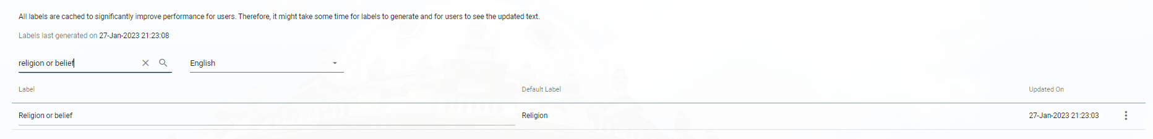

Workgroup

Workgroups are created and maintained by the System Administrator

Removing a ….
- Email notification

Navigate to: CoreHR > Utilities > HR Event configuration

For full details refer to the How To guide

- Payroll Calendar

Navigate to: Core|Portal>Back Office LINK > Admin Settings > Payroll Calendar Parameters

For full details refer to the How To Guide

- Workgroup

Navigate to: CoreTime > System Params > Work Groups.

NB: Workgroups are created and maintained by the System Administrator

Standard Icons & Terminology
Standard Button Names  Enter Query Mode button:  Previous Record button:   Previous Section button:   Save button:   Insert Record button:  | Execute Query button:   Next Record button:   Next Section button:   LOV button:   Delete Record button:  | Cancel Query button: 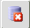  Red Door button:   Duplicate Record button: 
Navigation Paths

Show the final navigation path option in bold+italics, for example;

Core|Personnel > Reference > Reference A – C > Accident Codes
Core|Pay > Reference > Pay Groups

Any further navigation beyond the navigation path can be added after an ellipsis (…), for example;

Event Management > Event Configuration … HR Events > Change of Address

Other Standard Terminology

Testing
The HRIS Support Centre will be responsible for carrying out initial testing but it may also be necessary for others to take part in further testing.

Communications
Employees will need to be informed of any changes made to ESS and/or MSS. Dependant on the type of change this could be before or after the change has been implemented.

Downstream Systems & Processes
Details of any processes which are affected or need to be carried out following, or as part of, the change. Please detail any triggers, actions required and when the actions should be carried out.
HR Self Service guidance on the Using HRIS website

HR Self-Service webpages in the Staff Gateway

Affected Reports
Depending on the change(s) being made the following reports should be reviewed to establish whether any amendments are required.

PERDEP20 Monthly Personnel Changes
– There is a tab called ‘Changes made in Employee Self-Service’

PERDEP16_HR Self Service Work Groups

Additional Background Information
Employee Self Service and Manager Self Service were implemented following a year-long project in 2018. ESS is available to all employees with a CMS University contract of employment; MSS is available to all designated Self-Service Managers.

Users can access HR Self-Service from anywhere with an internet connection from any device via the University’s VPN (Virtual Private Network).

In the first phase of the project employees were given access to view current contract and pay information, view and update some personal details and view payslips and P60s. A welcome email is sent to new users by the Systems Administrator when their account is created.

The ability to update bank details was enabled but removed quite soon after implementation following concerns about validating the changes made. It is intended that this will be made available in a later phase.

Managers can view a list of the employees in their team, their contract details and some personal details.

Text in the Self-Service Portal can be edited in the Language pack – See How To above…….

Automated emails are configured e.g. when an employee changes their bank details. Navigate to People Management > Data Centre > HR Admin Setup Settings > Event Configuration. For full details refer to the Events and Email Notifications Knowledge Article.

Workgroups
Manager Self Service is reliant on work groups being created to which managers and employees are assigned. Each work group should have a manager assigned to it. Managers are assigned to work groups via People Management > Employee Administration > Maintain Organisation Roles

Employees are assigned to a Work Group for each appointment (excludes Casuals). The Work Group field in the Organisation Hierarchy has been enabled and appears after Location (see below).

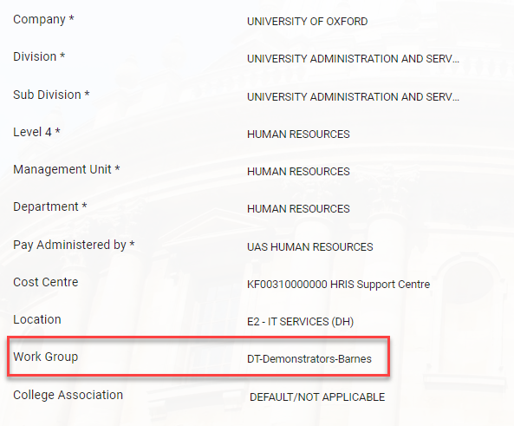

Workgroups are created and managed by the Systems (Security) Administrator.

Payroll calendar
On the Employee Self Service landing page, the date of the next Pay Day and the number of days to go is displayed in the ‘Important Dates’ section (see below).

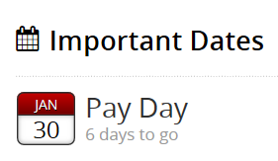

On the actual Pay Day, the legend says ‘today’. The day after Pay Day the next date is displayed.

A separate calendar is required for the calendar year for each Pay Group paid through payroll. At the present time we have calendars for pay groups 20 and 21.

In December each year new calendars will need to be created for the following year. It is not possible to overwrite an existing calendar to add dates for the following year so new calendars must be created. There does not appear to be any way to ‘direct’ the Pay Day view to a specific calendar, it seems to rely on the year in the SYSDATE matching the year on the Calendar. Thorough testing has been carried out on the process, the results of which can be viewed here.

Depending on when the December Pay Day falls there are two options for updating the calendars.

Option 1 (recommended) – add the January pay date for the forthcoming year to the current year’s calendars as a 13th Pay Date. This will allow plenty of time to create new calendars for the forthcoming year.

Option 2 – The day after December’s pay day, create new calendars for the forthcoming year and delete the calendars for the outgoing year. NB: The Next Pay Date section in the Portal will be blank until the new calendars have been created.

For details on how to create and edit these calendars refer to the How To guide - HOW TO - Maintain Payroll Calendar Dates in the Portal v 1.0.docx

Known Issues
There were some initial problems and queries generated after ESS was implemented. Some employees reported that their job title was incorrect and it transpired that the job title from their previous substantive appointment was being displayed – see details under ‘Known Issues’.

Incorrect Job Text displayed on the ‘home’ screen. The job text from a previous appointment is being displayed.

Incident 10575680. Raised with Eaton Square via Ray Stacey
Incident 10579308 Raised with Core #103306

Workaround advised by Core – Navigate to Personnel>Maintenance>Appointment History screen. Tick on the secondment indicator, save, then untick the secondment indicator. This should push missing data through to all tables.

Unable to view all appointments on the ‘home’ screen. An employee has four appointments but was only able to view two on the ‘home’ screen. Incident 10586157.
The employee was using a MAC and the scroll bar does not display unless you hover over the area where the scroll bar should appear.

Raised with Core # 104863.

Response from Core - Safari is not compatible with V20 although it is compatible with later versions. User confirmed that they were able to view the scroll bar by hovering over the area and can now see all four appointments.

Current months’ payslips not showing – this is reliant on payroll ticking the TBC

